**CLASS 01/02/2022**

**UG SEMESTER-3**

**GRAPH THEORY**



**Pendent vertex: A vertex with degree 1**

A tree with n vertices has n-1 edges. Hence degree of the tree 2(n-1) is distributed over n vertices. As no vertex has degree 0 we must have at least 2 vertices with degree 1 when n>=2.

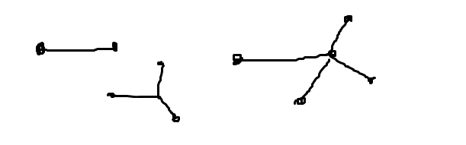

**Theorem:** In any tree with two or more vertices there are at least two pendant vertices.

**Distance between two vertices**

d(u,v)🡪distance between vertices u and v is defined as the length of the shortest path between u and v. It is valid for any connected graph.

**Metric:** Distance function between two vertices is a metric.

To be a metric any function f(x,y) should satisfy three conditions.

* Nonnegativity: f(x,y)>=0 and f(x,y)=0 when x=y
* Symmetry : f(x,y)=f(y,x)
* Traingle inequality: f(x,y)<= f(x,z)+f(z,y) for any z

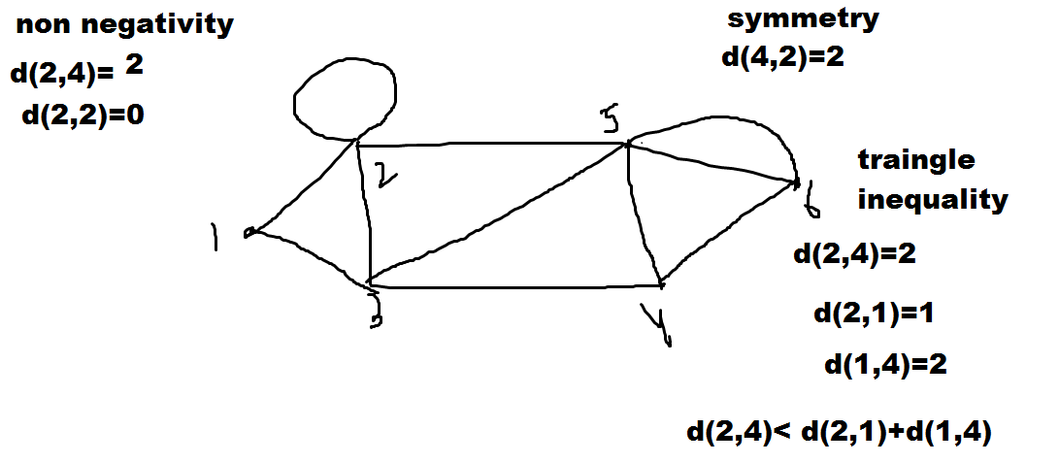

Distance function is a metric.

**Eccentricity**

The eccentricity E(v) of a vertex v in a graph G is the distance from v to thevertex farthest from v in G;

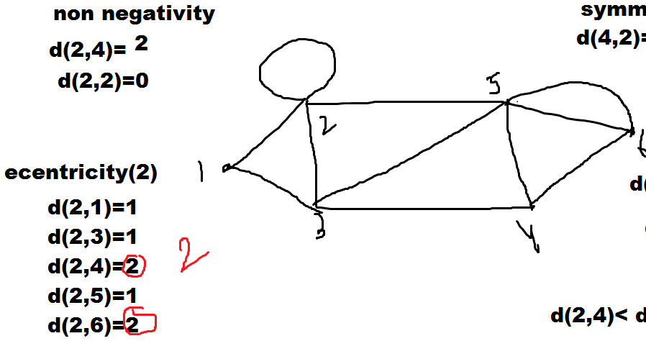

**Center:** A vertex with minimum eccentricity in graph G is called a center of G

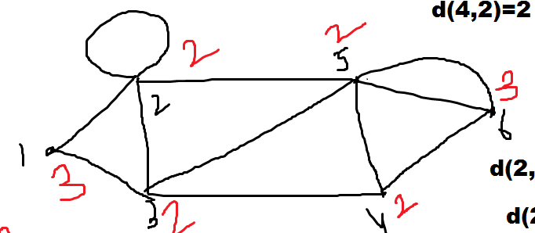

**There are 4 centers 2,3,4,5 vertices.**

**Theorem: Every tree has either one or two enters**

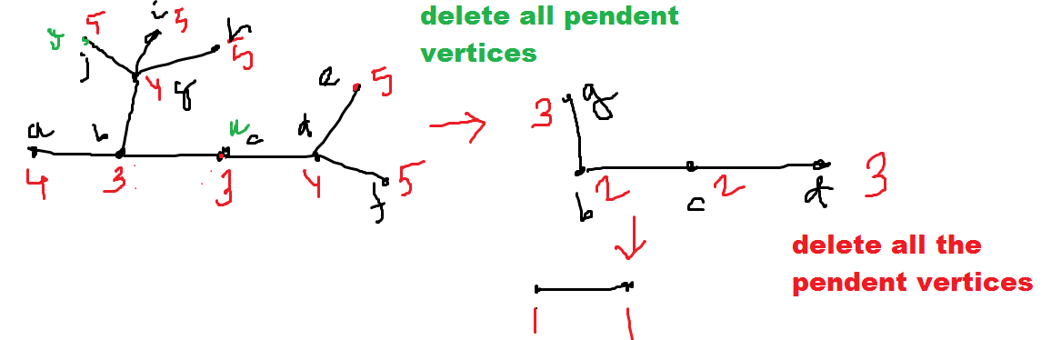

The maximum distance maxd(u,v) from a given vertex v to any other vertex u, occurs when u is a pendant vertex.Havinf considered this, let us start with tree T having more than 2 vertices. Tree T must have two or more pendant vertices. Delete all the pendant vertices from T. The resulting graph T’ is still a tree. Now removal of pendant vertices from uniformly reduces the eccentricity of all the remaining vertices by one. So the centers of T will also be the centers of T’. We gain remove all pendant vertices of T’ to get another tree T’’. We continue doing this until we get either a vertex or an edge. This final vertex(s) is the center of the tree.

**Radius and Diameter:**

The eccentricity of a center (which is the distance from thecenter of the tree to the farthest vertex) in a tree is defined as the radius of thetree.

The diameter of atree T, on the other hand, is defined as the length of the longest path in T

**Rooted tree.** A tree in which one vertex (called the root) is distinguished from all the others is called a rooted tree.

**Non-rooted tree/ free tree**

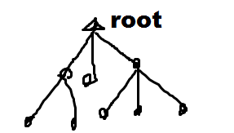

**Binary Trees:**A binary tree is defined as arooted tree in which there is exactly one vertex of degree two, and each of the remaining vertices is of degree one or three.

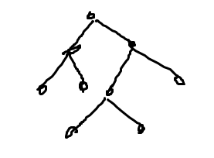

* **The number of vertices n in a binary tree is always odd**

1(root)🡪2, remaining (N-1) vertices has degree 1 or 3

N must be odd

* **Let p be the number of pendant vertices in a binary tree T.**

(n-p-1) vertices has degree 3

degree of root 2

From degree eqality

p+(n-p-1)*3+2=2(n-1)

p=(n+1)/2

Number of Internal vertex =n-(n+1)/2=(n-1)/2

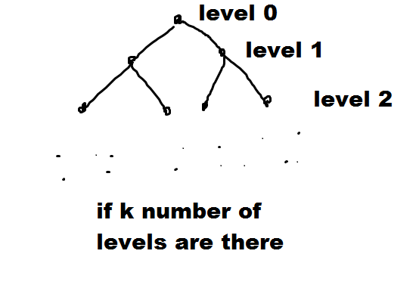

where n is the number of vertices in the binary tree.

when every level is filled up except the last level.

Evaluating we get the maximum level with n vertices,

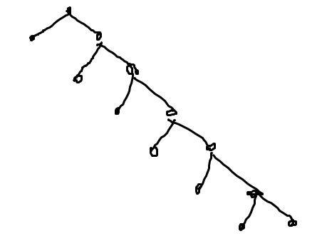

1. **Unlabelled Tree 2) Labelled tree**

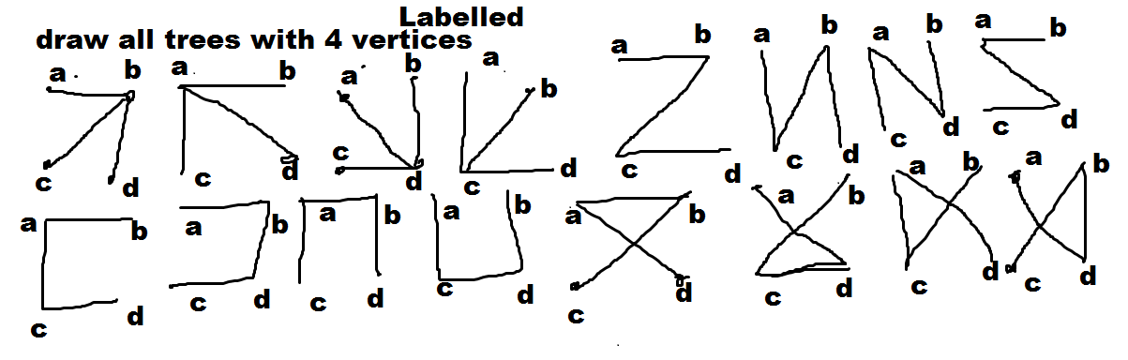

**In 1857 Arthur Caley discovered trees while studying the number of structural isomers of saturated hydrocarbons**

**k=1 CH4 = methane**

**k=2 C2H6=ethane**

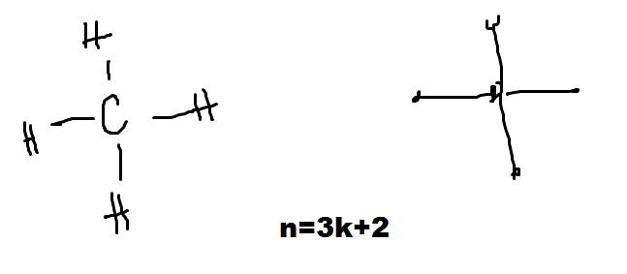

Hydrocarbons are plotted as trees with n=3k=2 vertices.

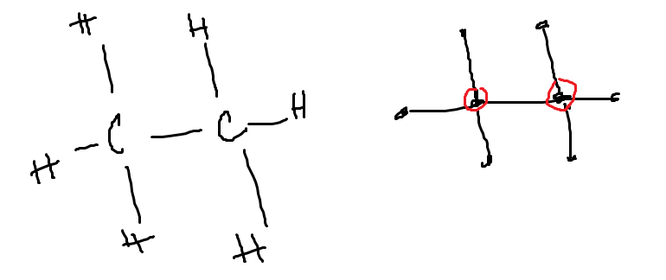

**Labelled Graph:**A graph in which each vertex is assigned a unique name or label (no two vertices have same label) is called a labelled graph.

**What is the number of different trees that one can construct with n labelled vertices?**

**Caley’stheorem :The number of labeled trees with n vertices (n ≥ 2) is**

Traditionally, the vertices of a tree are labelled by integers 1,2,3,……,n where n is the number of vertices in tree.

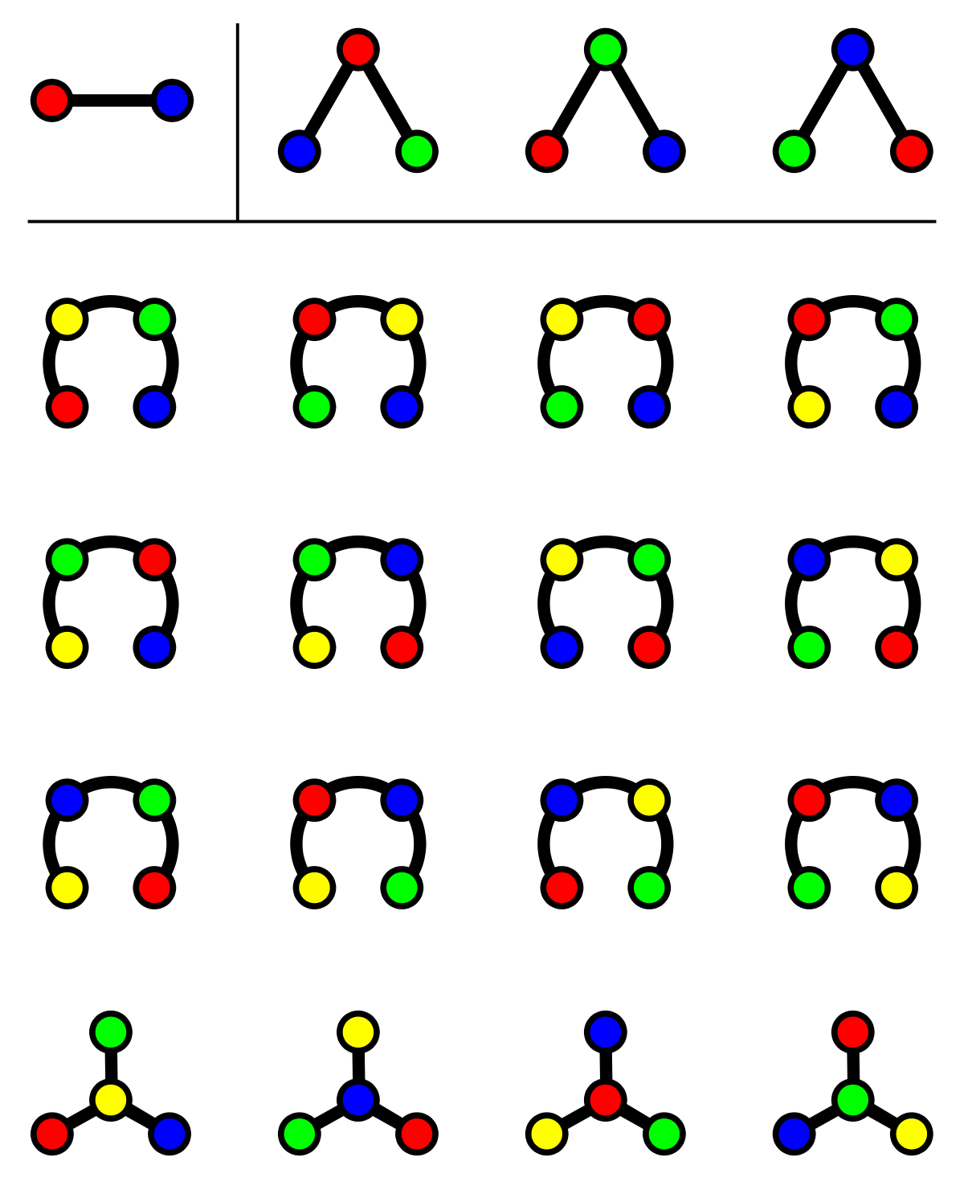

**Prufer Sequence:**  A sequence S, is a sequence of n-2 numbers ,each being one of the numbers 1 through n.

Proof: Basic idea of this proof is to show that a labelled tree T has one to one correspondence (i.e. bijection) with Prufer sequence. If yes then of course number of labelled trees is equal to number of Prufer sequences.

The following is an algorithm that can be used to encode any tree into a Prufer sequence:

Step 1. Find a pendant vertex say v of T with smallest label

Step 2: Add the adjacent vertex of v to S and delete the pendant vertex from T.

Step 2. Repeat step 1 & 2 until there are 2 vertices left.

This will give us a Prufer sequence of length (n-2).

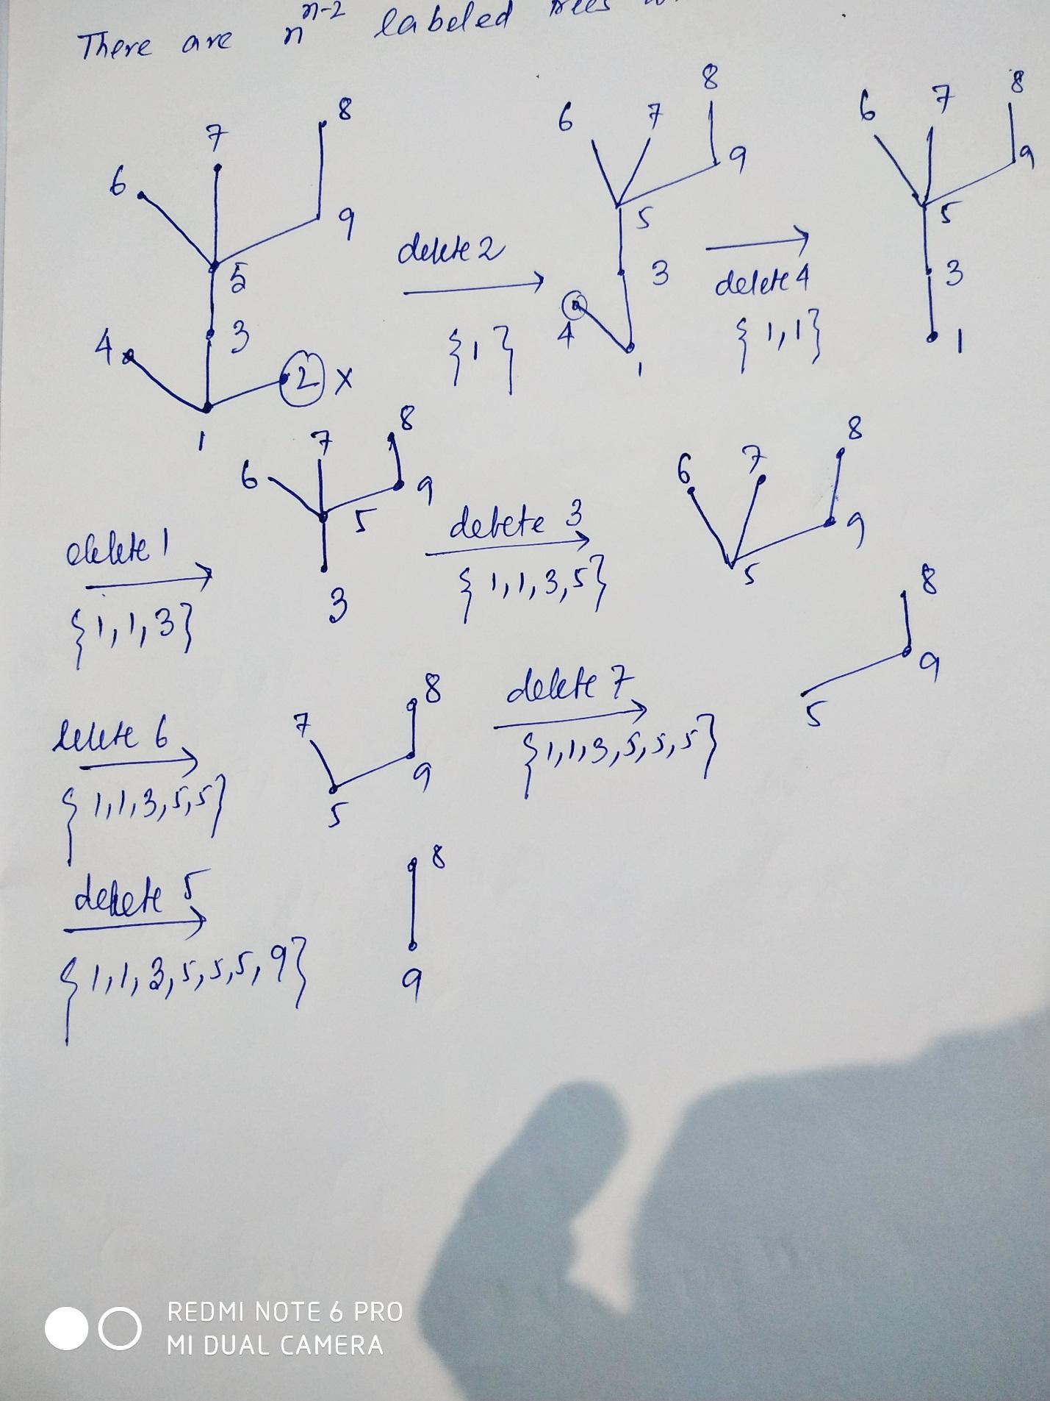

**Prufer sequence={1,1,3,5,5,5,9} 7 elements.**

This is unique encoding of a tree because,

First, we must notice that all of the vertices of degree 1 don’t occur in the sequence S.

In fact, it follows from this that every vertex has degree equal to 1 + a, where a is the number of times that vertex appears in S.

**Converse:** Given a Prufer sequence S, on n-2 elements, determine uniquely a labelled tree on n vertices.

1. Find the smallest number from 1 to n that is not in the sequence S and attach the vertex with that number to the vertex with the first number in S. (We know that n = 2 + number of elements in S.)

2. Remove the first number of S from the sequence. Repeat this process

considering only the numbers whose vertices have not yet attained their correct degree

3. Do this until there are no numbers left in S. Attach the last number in S to vertex n.

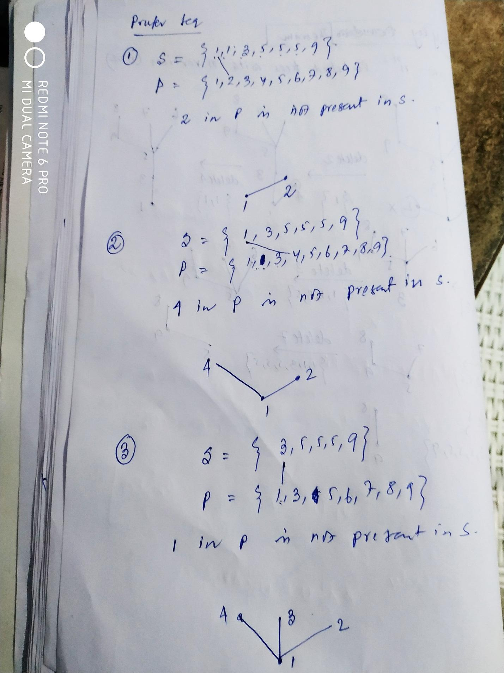

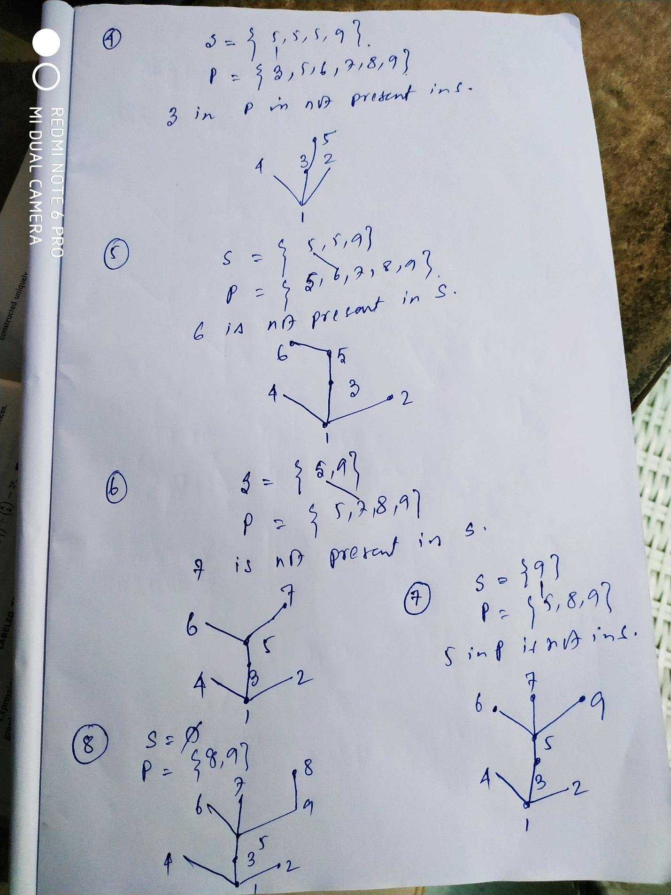

So we are getting the same unique tree from the Prufer encoding of the tree.

So there exist a bijection between a labelled tree and a Prufer sequence.

Now a tree with n labelled vertices has a Prufer sequence (i.e. encoding) with length (n-2) each of the member of the sequence have values from 1 to n.

So total number of Prufer sequences is

=n x n x ………………xn for(n-2 terms)

= n (n-2)

Hence total number of labelled trees is n (n-2). **(Proved)**